|  |
| --- |
| genweb2 ltd. |
| Samuda User Manual |
| REFERENCE: GW/ERP/USER MANUAL |
|  |
| **Genweb2 Ltd.** |
| **02-May-17** |

|  |
| --- |
| logo.png  **Genweb2 Limited**  TK Bhaban (11th Floor),  13 KaziNazrul Islam Avenue,  Kawran Bazar, Dhaka 1215, Bangladesh  web: [http://www.genweb2.com](http://www.genweb2.com/) |

Contents

1. Payroll Management 3

1.1 Create Salary Structure 3

1.2 Creating Payslips Batches 3

1.3 Generate Employee Paysilips 5

1.4 Creating Loan Request for Loan Deduction 6

1.5 Creating Meal Bills for Mess Deduction 7

1.6 Creating Mobile Bill Limits for Mobile Bills Deduction 7

1.7 Creating Mobile Bills for Mobile Bills Deduction 8

1.8 Creating Contract Details for Each Employee 8

# 1. Payroll Management

## 1.1 Create Salary Structure

First we need to create salary structure.

Navigation Menu:  **Payroll >>Salary Structure >> Create**

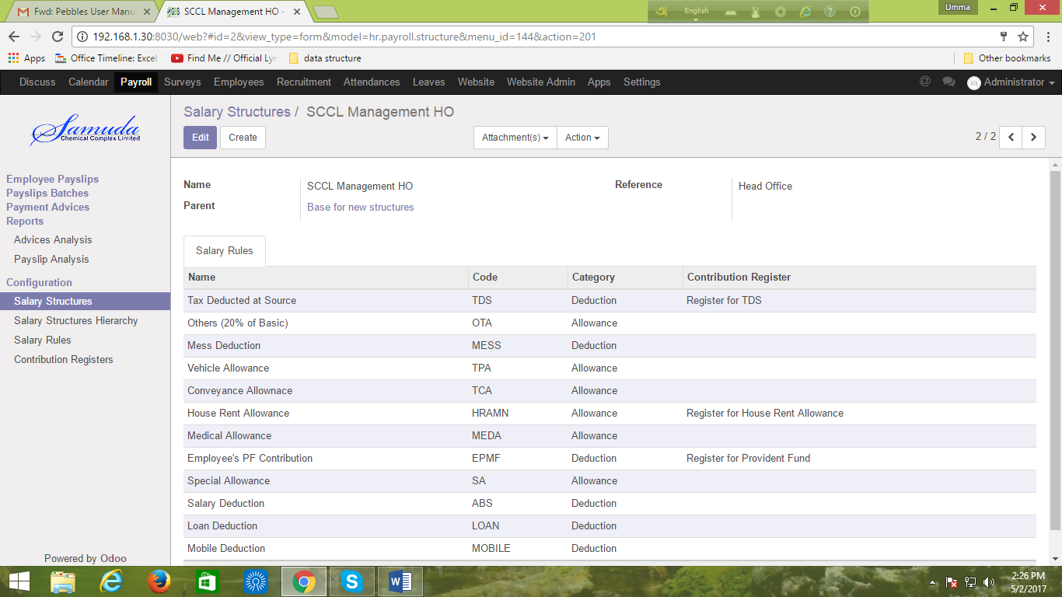

Figure: Create Salary Structure

## 1.2 Creating Payslips Batches

We need to create Payslips Batches.

Navigation Menu: **Payroll >> Payslips Batches>> Create**

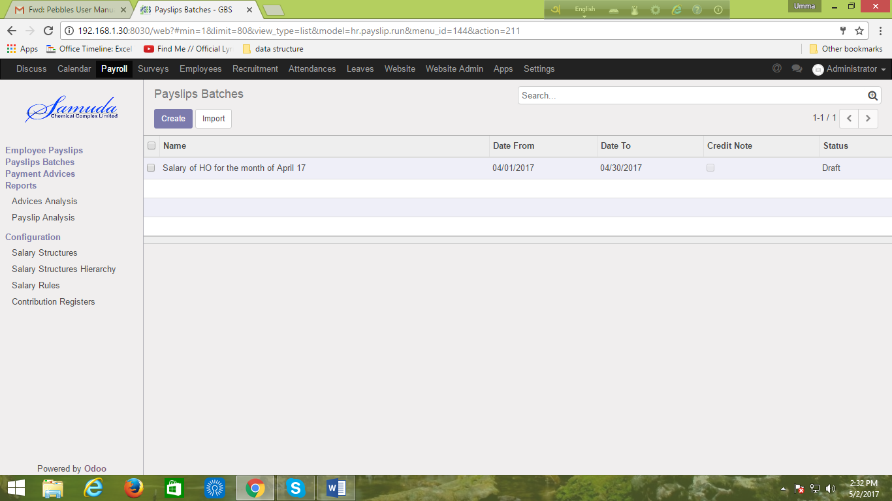

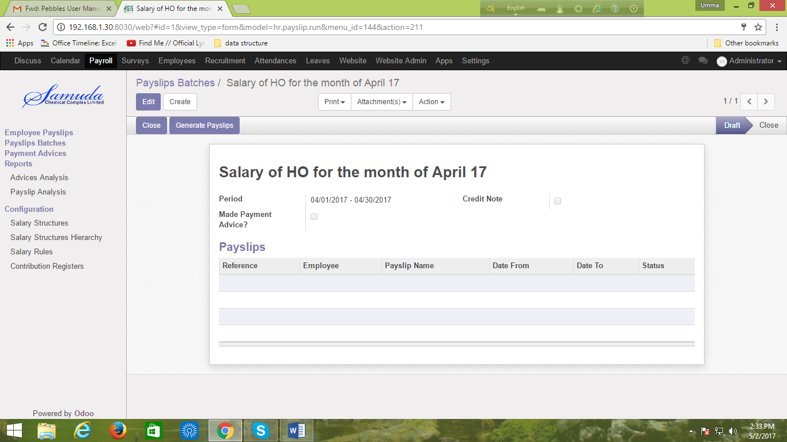

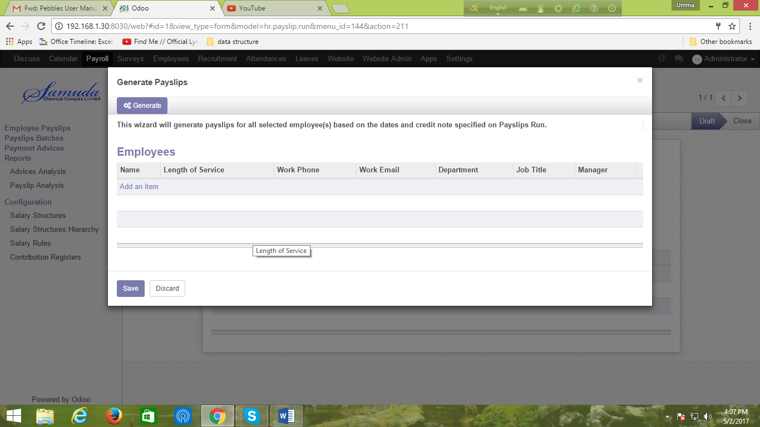

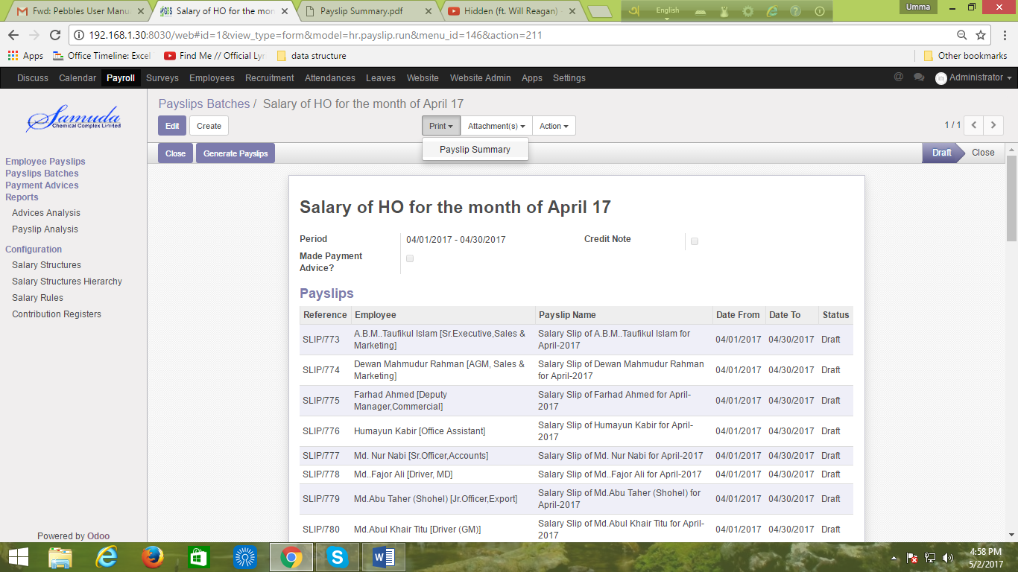

Figure: Create Payslips Batches

## 1.3 Generate Employee Paysilips

Then we need to Generate Employee Paysilips.

Navigation Menu: **Payroll >> Employee Paysilips**

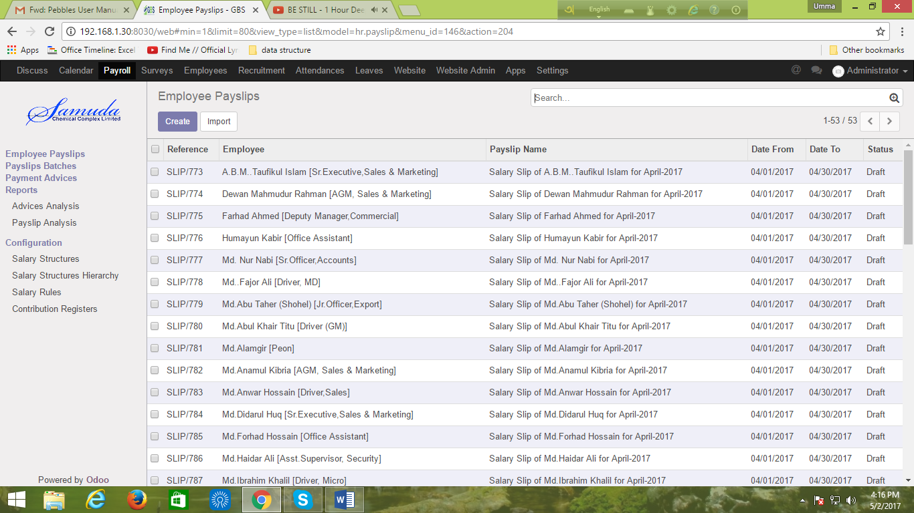

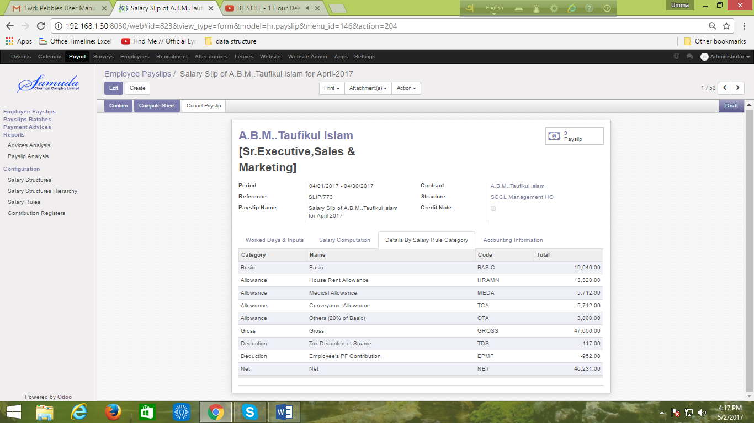

Figure: Generate Employee Paysilips

## 1.4 Creating Loan Request for Loan Deduction

First we need to Creating Loan Request

Navigation Menu: **Employee >> Loan requests >> Create** 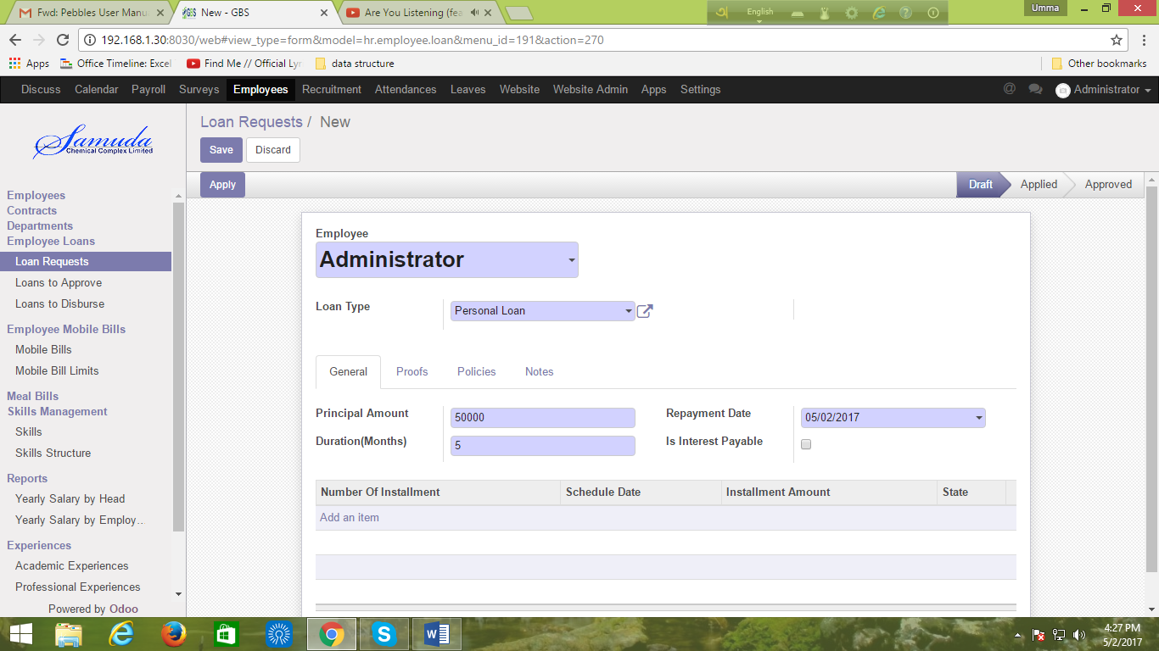

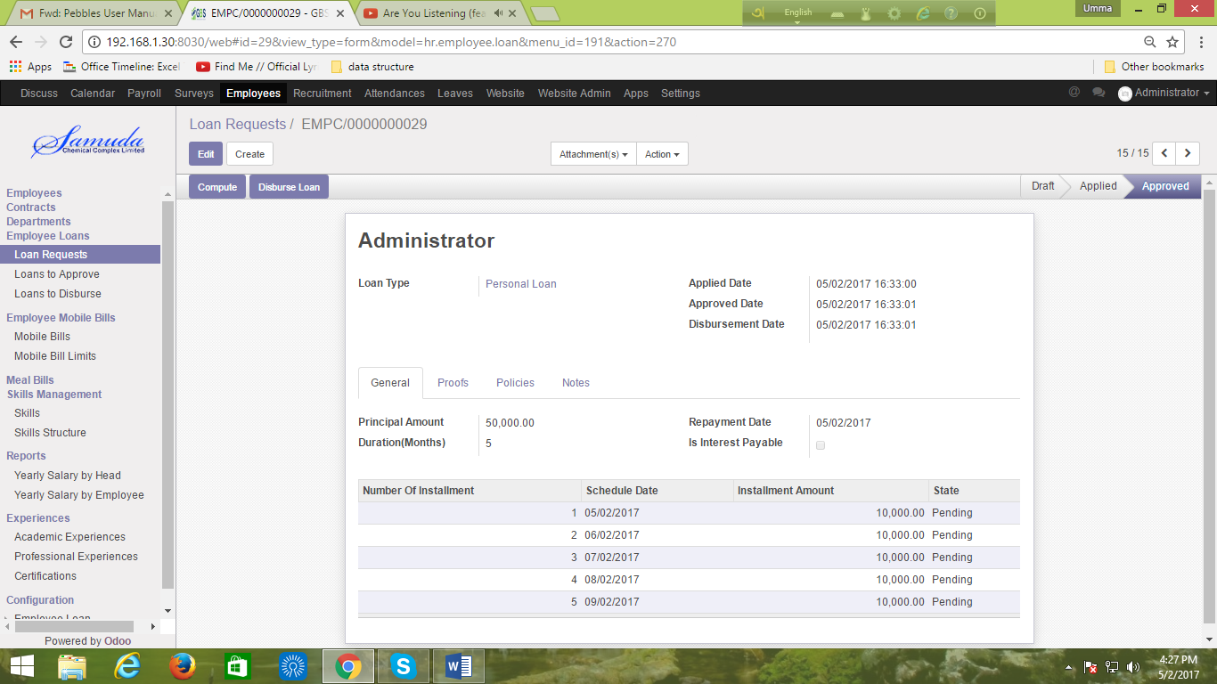

Figure: Create Loan Requests

## 1.5 Creating Meal Bills for Mess Deduction

Now we can Creating Meal Bills.

Navigation Menu: **Employee >> Meal Bills >> Create**

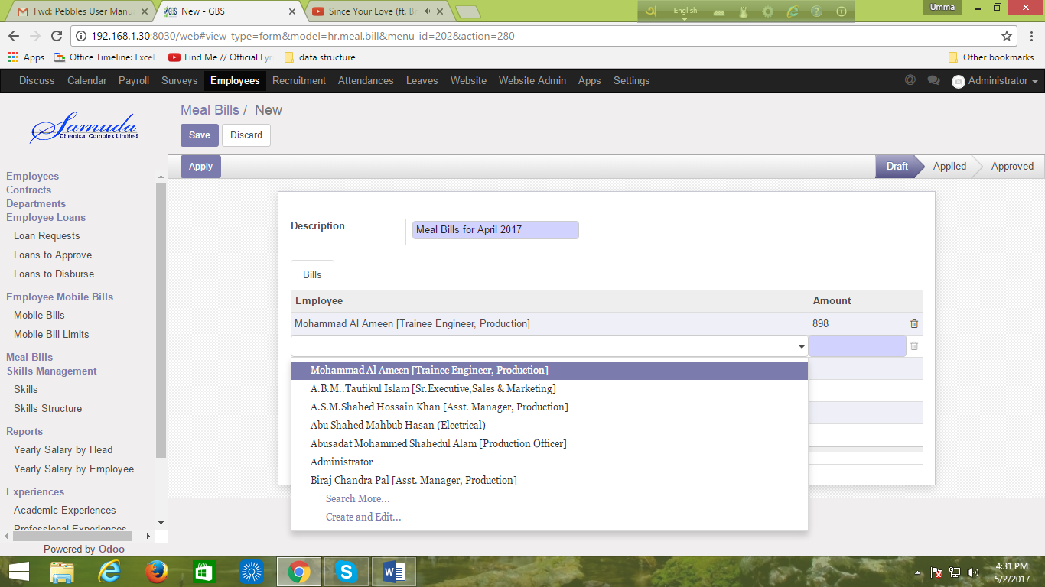

Figure: Creating Meal Bills

## 1.6 Creating Mobile Bill Limits for Mobile Bills Deduction

Now we can Creating Mobile Bill Limits.

Navigation Menu: **Employee >> Mobile Bill Limits >> Create**

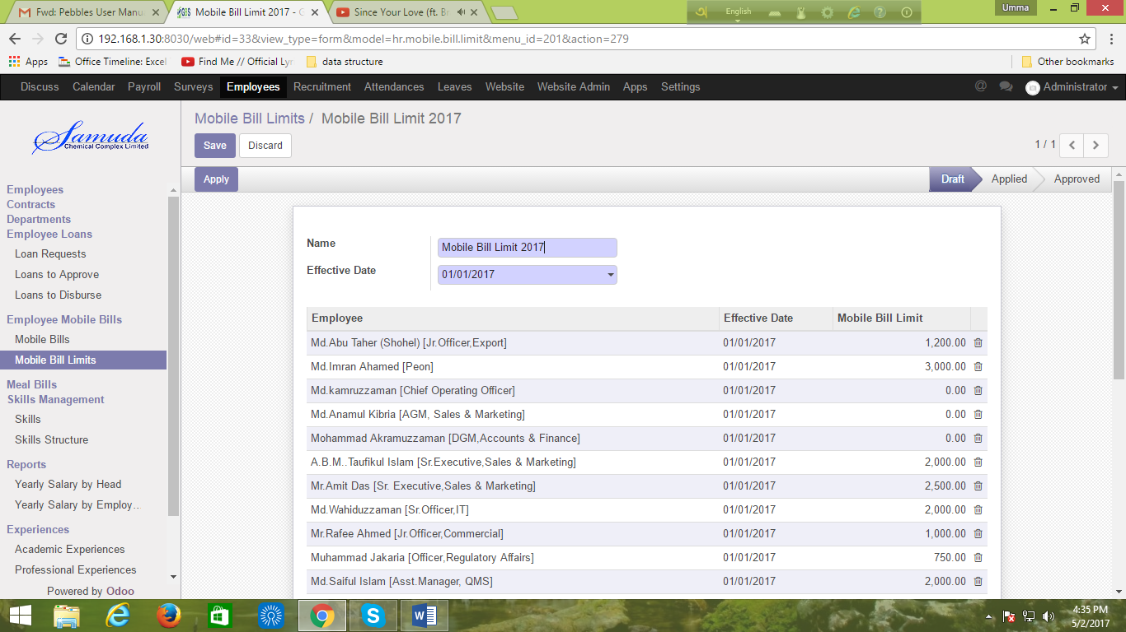

Figure: Creating Mobile Bill Limits

## 1.7 Creating Mobile Bills for Mobile Bills Deduction

Now we can Creating Mobile Bills

Navigation Menu: **Employee >> Mobile Bills >> Create**

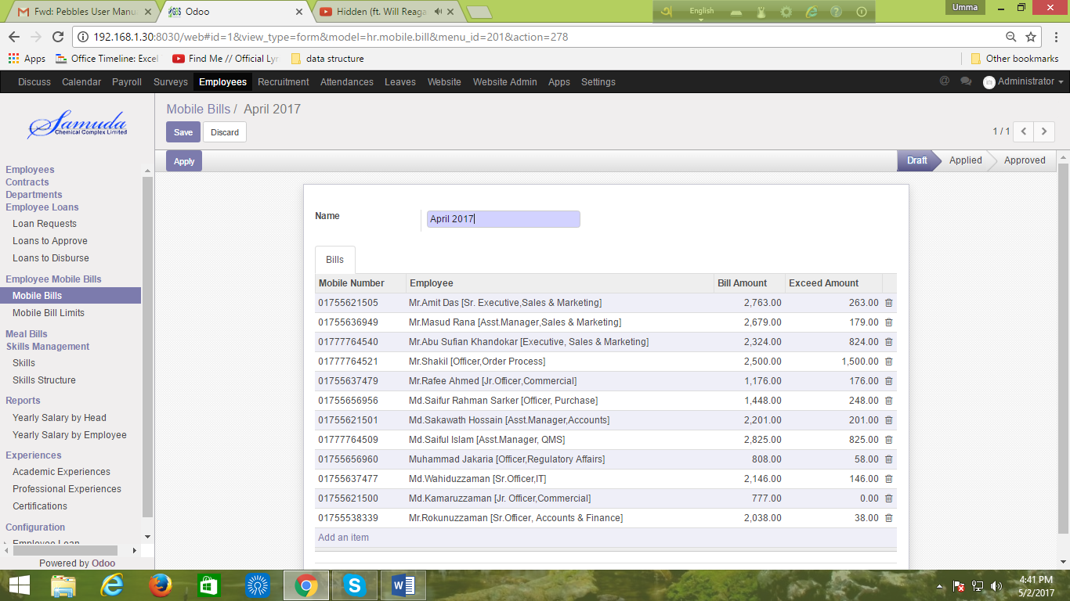

Figure: Creating Mobile Bills

## 1.8 Creating Contract Details for Each Employee

Now we can Creating Contract Details.

Navigation Menu: **Employee >> Contracts >> Create**

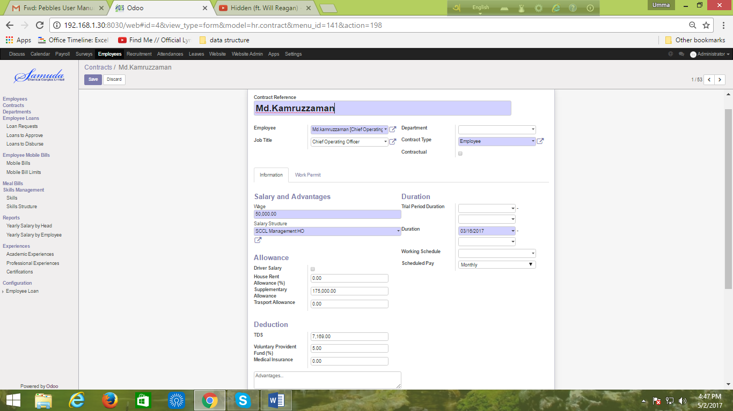

Figure: Creating Contract Details